**EXPERIMENT-11**

Demonstrate virtualization by Installing Type-2 Hypervisor in your device, create and configure VM image with a Host Operating system (Either Windows/Linux).

**Implementation:**

**Step-1:**

Open VMware and select “Create a new virtual Machine”

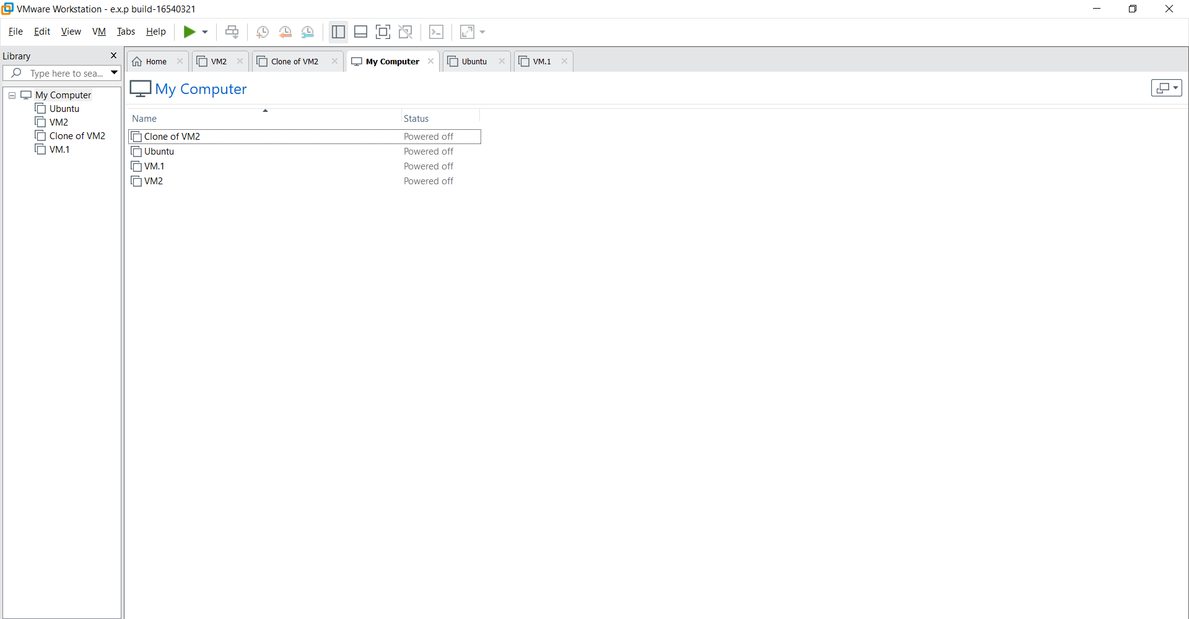

**Step-2:**

Do the basic configuration settings.

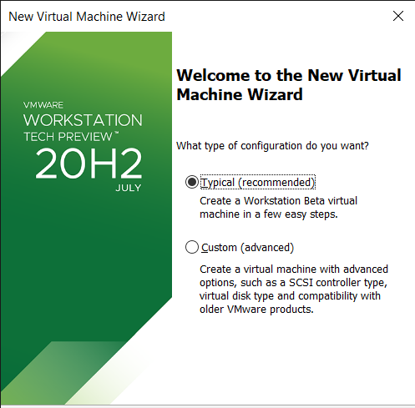

**Step-3:**

Select disk image file option and load the OS file.

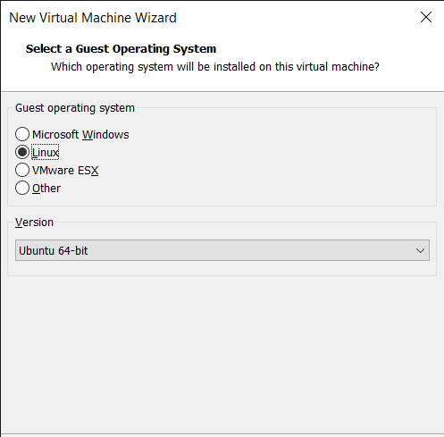

**Step-4:**

Create new user name and password.

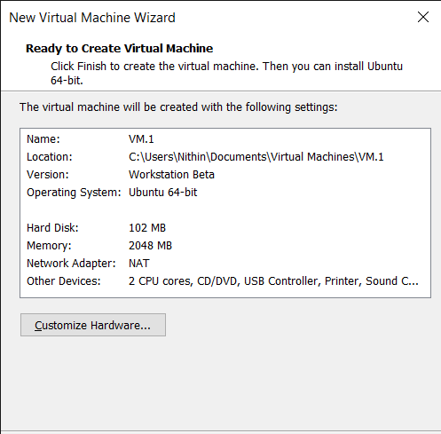

**Step-5:**

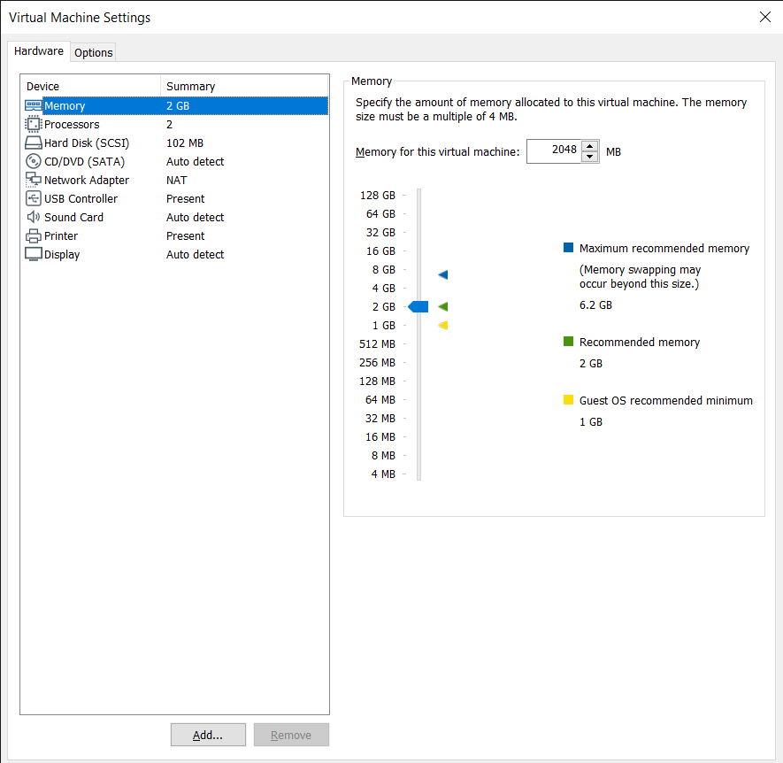

**Step-6:**

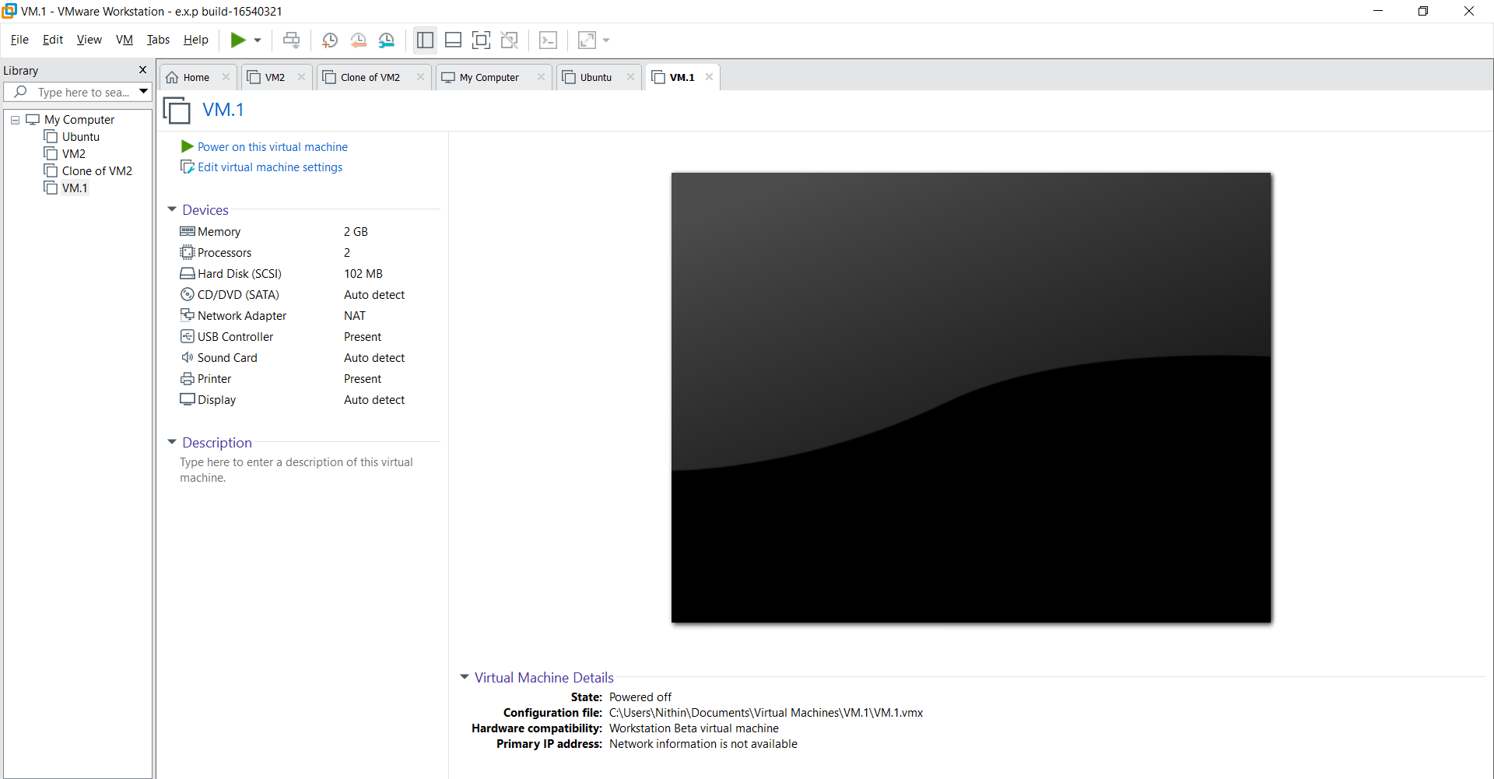Launch the Virtual Machine.